- \Operation\Tube filling\Dosing\Tube filling – dosing – timing (page 1 of 2)
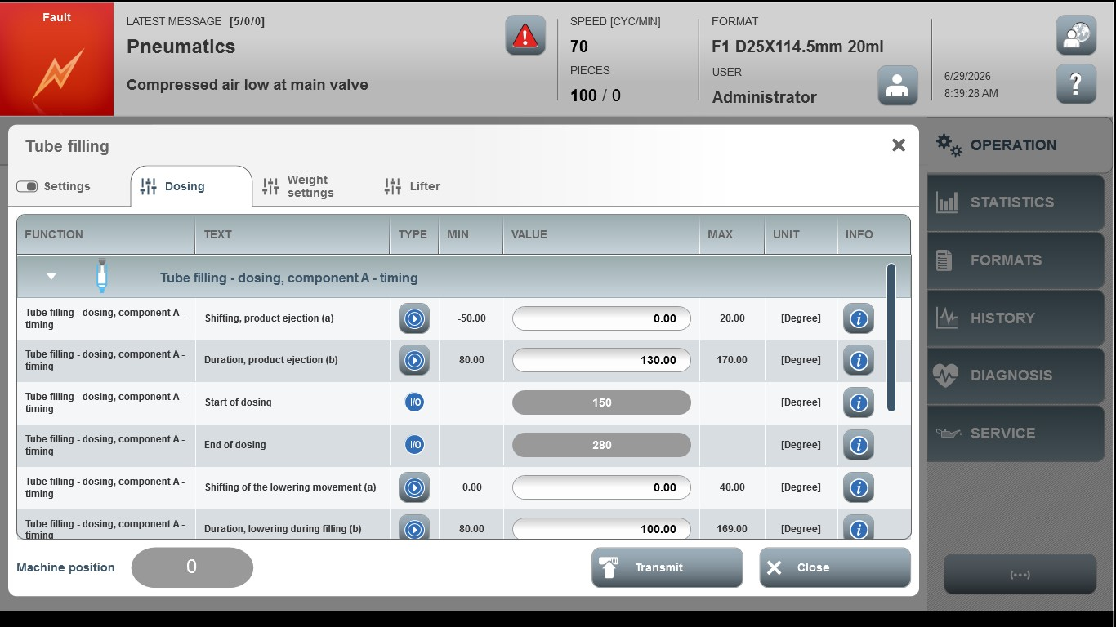
Acceptance criterion | Limits | Pass / Fail: Dev-No. |  | Date | Initials
Screen matches screenshot | N / A
Shifting, product ejection (a) | -50.00…20.00
Duration, product ejection (b) | 80.00…170.00
Shifting, of the lowering movement (a) | 0.00…40.00
Duration, lowering during filing (b) | 80.00…169.00
- \Operation\Tube filling\Dosing\Tube filling - dosing– timing (page 2 of 2)
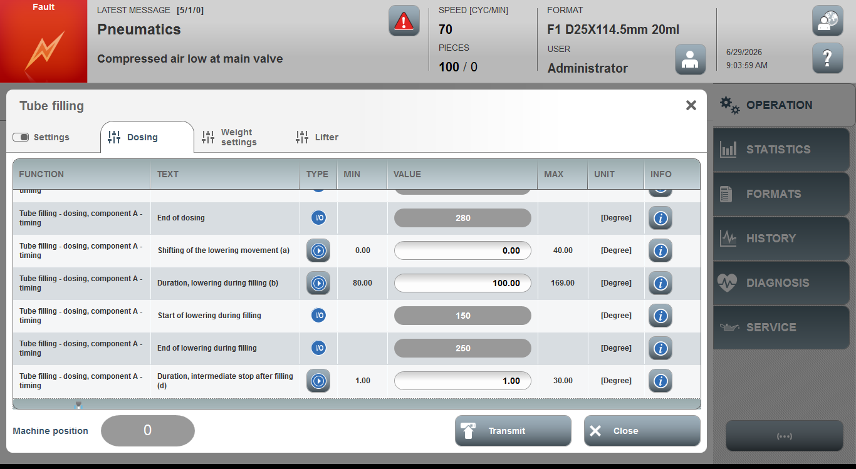

Acceptance criterion | Limits |  | Pass / Fail: Dev-No. | Date | Initials
Screen matches screenshot | N / A
Duration, intermediate stop after filling (d) | 1.00 … 30.00

